Non-orthogonal dipole equations with Ohmic currents

In the non-orthogonal coordinates, Faraday’s Law is:
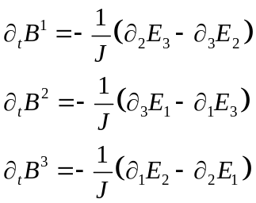
Write Ampere’s Law in terms of the displacement vector D:
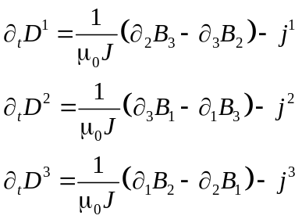
Here we can write the displacement in terms of the electric field using the dielectric tensor:
Here is the unit vector in the direction of B₀, which is the basis vector e₃ divided by its magnitude, given by 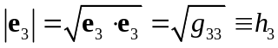. Thus,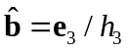 and 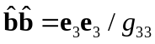. So we get
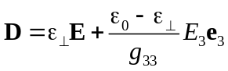
Since we have 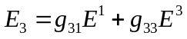, we can write this in component form, noting 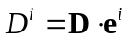, etc. as
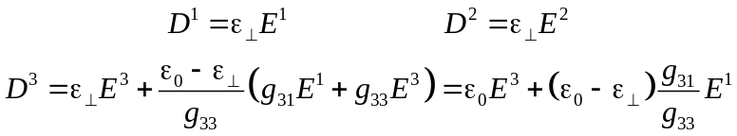
This can be inverted easily to give
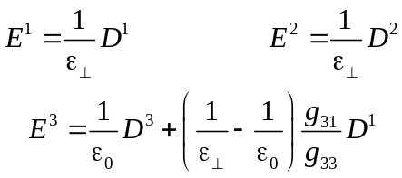
For the perpendicular equations, these can be easily written in terms of E, writing 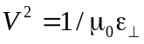:
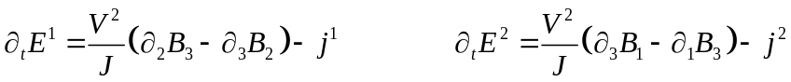
The E³ equation appears more complicated. However, it is easier here to think in terms of the covariant component. In this case, dotting equation with e₃ gives D₃ = ε₀E₃, so the covariant version of Ampere’s Law becomes
Now we need to calculate the ionospheric current, with the additional complication being the Hall current. In vector form the current is
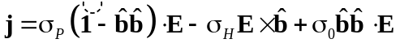
The first and last terms are the similar to those for D in equation , other than the Hall term, which can be written as
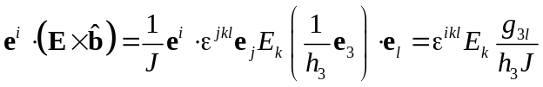
The relevant components of this expression are
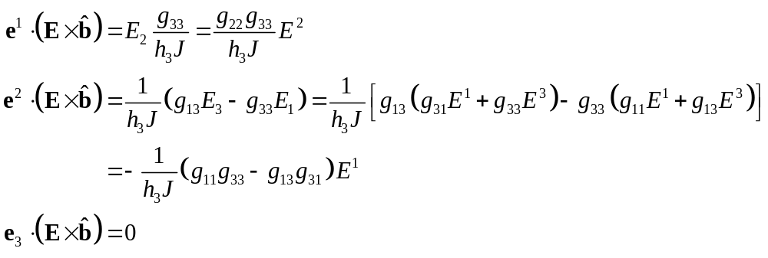
So the contravariant components of the perpendicular current are:
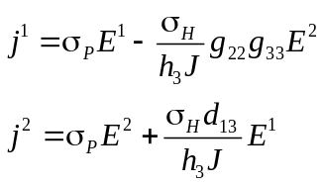
Where 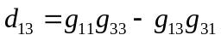 is the determinant of the poloidal components of the metric tensor, and the parallel component is 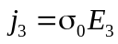.
So the equations for the electric field become
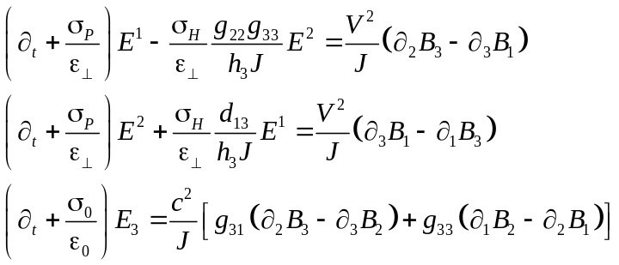
Since σ₀ is usually big and ε₀ is small, it is convenient to neglect the time derivative in the last equation and write
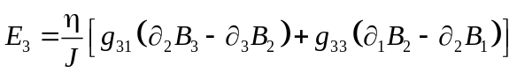
Where 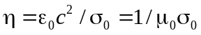 is the diffusivity

Modeling the ionosphere with integrating factors

Consider the simplified system described by perpendicular equations in . We can write this in the form
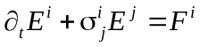
Where 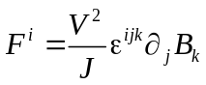. The mixed conductivity tensor can be written as
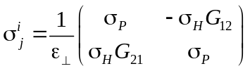
Here the G factors contain the geometry:
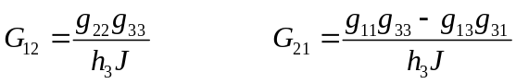
Thus, the equations can be explicitly written as
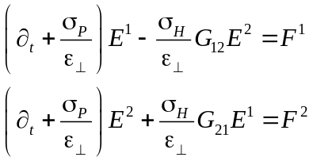
Note that 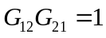 since 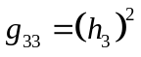 and 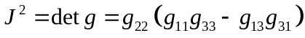. We want to diagonalize the matrix σ. The eigenvalue equation is 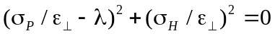 which can be readily solved to give
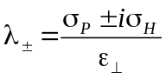
Inserting these into the first row of the eigenvalue equation 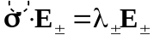, we can find (unnormalized) eigenvectors
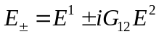
Taking the first equation of ±iG₁₂ times the second equation, we find
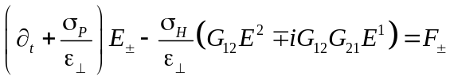
Here F± is defined in analogy with E± in . Since , we can write as
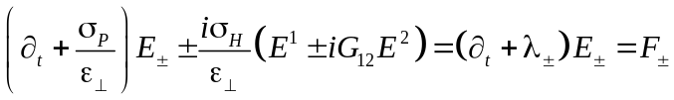
Now we can define 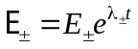. Then we have 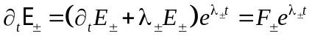. Since F is staggered in time with respect to E, this equation can be simply integrated
Or in terms of the original electric fields, after canceling out a factor of 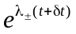,
We can recover the original variables by noting that
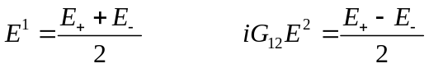
So that we have
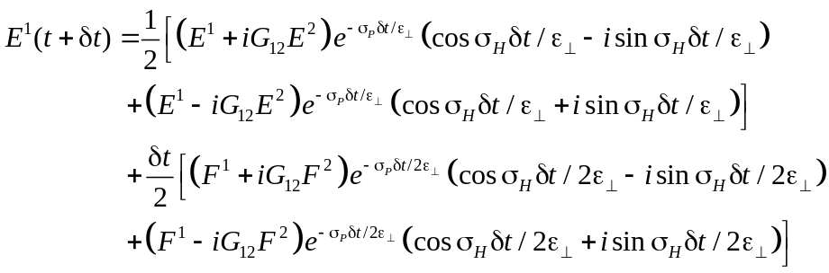
Or collecting terms
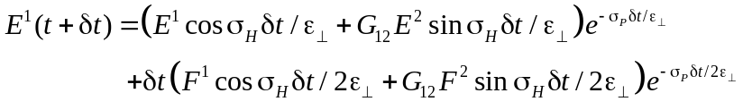
Performing similar operations on the difference of the two equations, and again using , we get
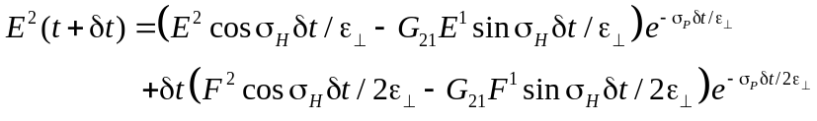
The parallel equation can be treated in a similar manner. Writing the right-hand side of as F₃, we can solve as in equation :
This form has the advantage that in the limit of infinite conductivity, the exponential factors are zero, ensuring E₃ = 0. Additional terms, such as the current associated with electron inertia, can also be included.

Rotation between contravariant and covariant components

Equations advance the contravariant components of the fields; however, the covariant components are needed on the right-hand side. For the magnetic field, this transformation is straightforward:
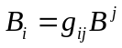
For the electric field, we calculate the covariant component E₃, so we need to find the covariant component E₁ from E¹ and E₃. So we invert the relation
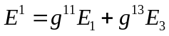
To get:
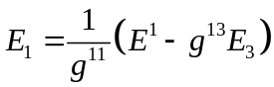

Defining the grid

The coordinate system is based on the non-orthogonal coordinate system as described in Lysak (2004):
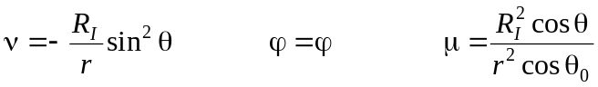
These coordinates correspond to the following contravariant and covariant basis vectors:
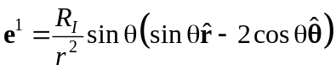
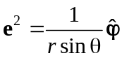
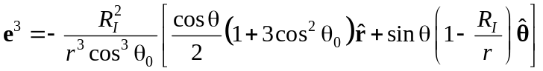
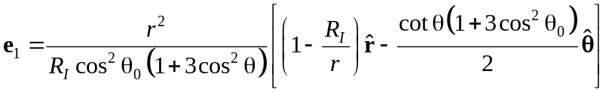
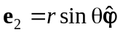
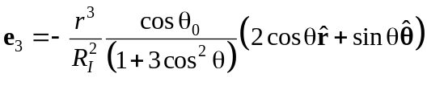
And these give the following components of the metric tensor:
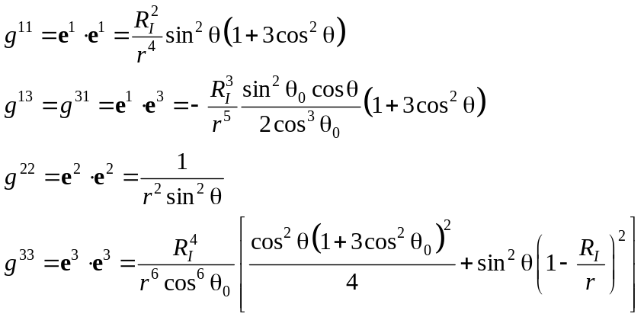
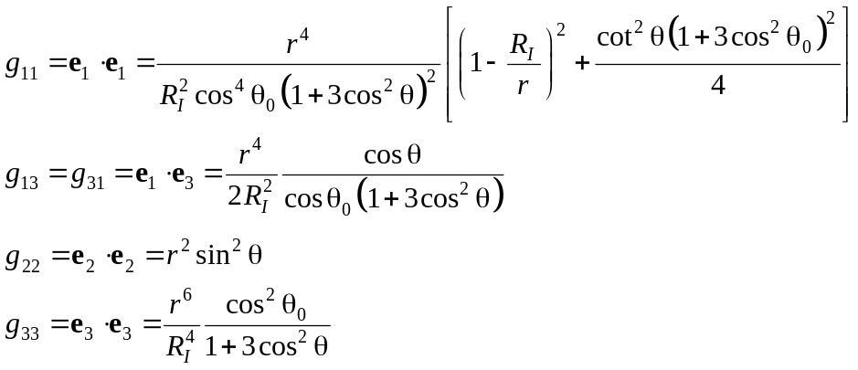
The Jacobian is given by
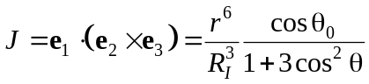
Note that in these expressions, cos θ₀ is taken to be always positive, while cos θ will be positive in the northern hemisphere and negative in the southern. We set up the grid to be uniform in the first two coordinates, so that u¹ = ν and u² = φ, but since we want high resolution near the ionosphere but don’t need it near the equator, we want to vary rescale the parallel component. This is done by choosing a reference field line and calculating the path length along this field line, noting that
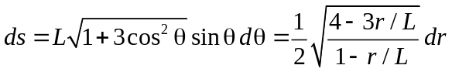
The parallel grid is generated by taking a desired form for the grid spacing (in the version implemented on 3 May 2011, the grid spacing increases linearly from a minimum value at the ionosphere to a maximum value at the top boundary, so that the grid points are quadratic in the path length. Equation is then integrated on a dense grid in cos θ and inverted to find the value of cos θ for each grid point, so that r can be determined from the field line equation (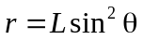) and μ can be found from . The coordinate u³ is defined to be the grid number, and the derivative dμ/du³ is found by central differences (forward/backward differences for the end points). The grid points on all other field lines are taken to be at the same μ with r found by a Newton’s method solution of the 4th order polynomial that results, so that
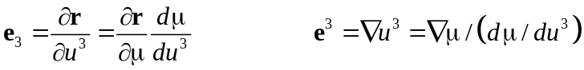
Thus, in equations -, all terms that involve e₃ are multiplied by this derivative and those involving e³ are divided by this derivative. Specifically, g₁₃ and the Jacobian are multiplied by dμ/du³, g₃₃ is multiplied by this factor squared, and g¹³ and g³³ are divided by this factor and its square, respectively.

Top and side boundary conditions

The top boundary is implemented by specifying the driving perpendicular electric field, and then assuming that this represents the only downgoing wave. This accomplished by setting the ratio of electric-to-magnetic fields to be the local Alfvén speed. Including the appropriate scale factors, we can write this as
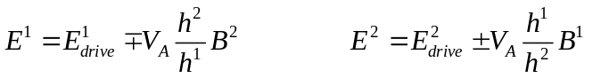
Here we have 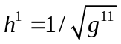 and 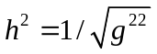, and the top (bottom) signs are for the northern (southern) hemisphere. Note that 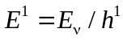 and 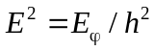 where E_{ν} and E_{φ} are the physical fields.

The boundary conditions on the high and low-latitude boundaries are that B¹ and E₃ are zero, and either B³ or E² are zero. We will refer to the B³ condition as Dirichlet and E² as Neumann because of their nature on the atmospheric boundary condition below. Other components on the boundary are found using backward/forward differences in u¹ as necessary.

Atmospheric Boundary Condition

We want to implement a boundary condition to calculate the magnetic perturbation below the ionosphere. We assume this region has zero conductivity and so no currents; therefore we can write 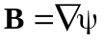 where ψ satisfies Laplace’s equation. This will be calculated in terms of a spherical harmonic expansion. The first step is to determine the basis functions in terms of Legendre polynomials, written in terms of the variable u¹ = u = −(R_{I}/r) sin²θ, where R_{I} is the assumed ionospheric height.

The usual form of Legendre’s equation in terms of 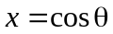 is
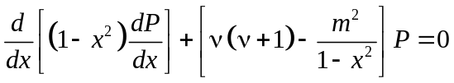
At the inner boundary, we have 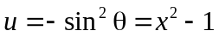, so differentiating gives
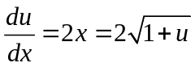
So since 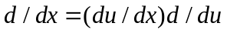, we have
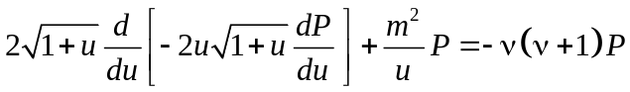
Noting that
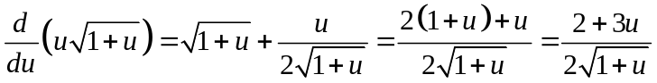
Legendre’s equation becomes (pulling out a minus sign):
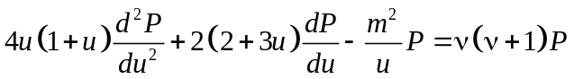
Or, using central differences
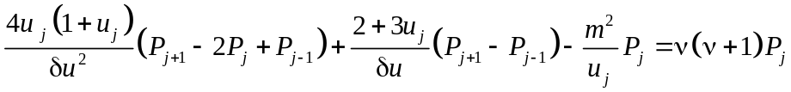
For j ranging from 0 to J, we can find these functions by solving the eigenvalue problem defined by equation , defining the eigenfunctions as 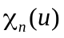. Either Dirichlet or Neumann boundary conditions can be used. Note that since radial magnetic field is proportional to B³ and that 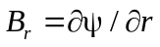, ψ will satisfy Dirichlet or Neumann conditions corresponding to the boundary conditions of B³.

Then, a general function of u can be defined by
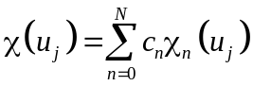
Here we will use letters from i to l to label grid points and m to q to label the modes. We find the eigenfunctions by solving equation from j = 1 to J−1, using forward and backward differences to define the endpoints:
In general, this will give N = J−2 eigenmodes with eigenvalues λ_{n} = ν_{n}(ν_{n}+1). These eigenfunctions are normalized so that
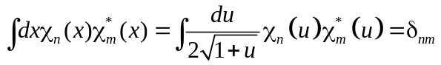
Now we can write
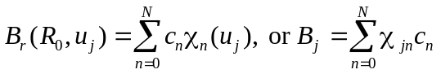
Where the last form casts this as a matrix equation. Note also at this point we can reduce the maximum mode number N so that the higher modes that oscillate on the grid scale are suppressed. In this matrix form we can write the orthogonality condition as
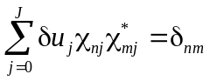
Where 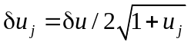 (recall that the grid spacing δu is constant). Normally, you would think of inverting 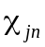 in equation to determine the coefficients c_{n}. However, since this is not a square matrix, its inverse is not well defined. This can be resolved by multiplying equation by the transpose of this matrix, to get (using the summation convention):
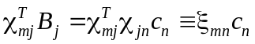
Now 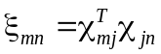 is a square matrix, and can be inverted. Therefore
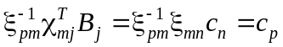
Now, letting B = ∇ψ, in the atmosphere ψ satisfies Laplace’s equation ∇²ψ = 0, and in spherical coordinates this solution can be written as
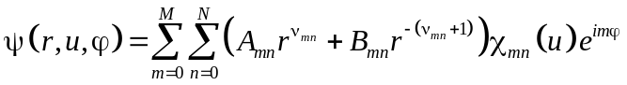
Here the m dependence is expressed explicitly for completeness, but it will be suppressed from now on since in the 2d code, m is fixed, as will the e^{imφ} dependence.

Differentiating equation , we get the expression for B_{r}:
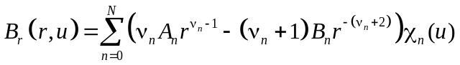
Applying the boundary condition that B_{r}(R_{E}) = 0, we get
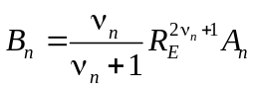
Then equations and become
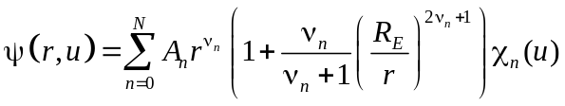
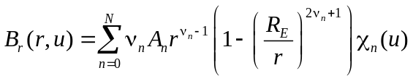
Comparing this expression with we get
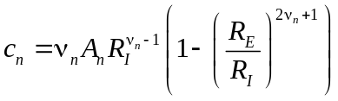
And so becomes
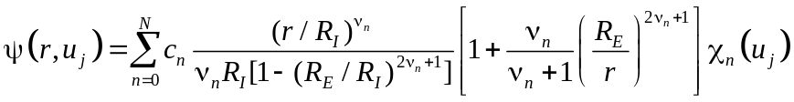
Evaluating this at the top and bottom boundaries of the atmosphere:
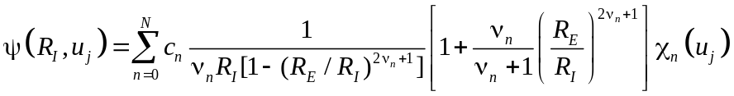
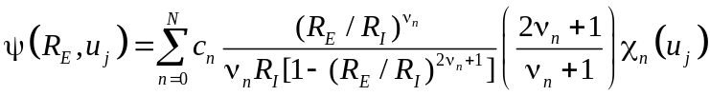
We can write these in matrix form as
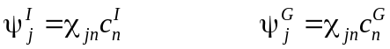
where
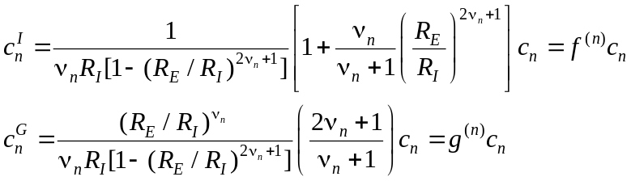
where the (n) is written as a superscript to emphasize there is no summation. Then the scalar potential at the ground can be written in terms of the radial magnetic field as
The quantities in the parentheses can be calculated at the beginning of the run, so that determining the ψ at each time step is a matrix multiplication. As one final step in the calculation, we should note that the radial component B_{r} at the ionosphere is proportional to B³ since from we have
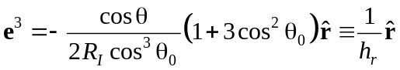
so that B_{r} = h_{r}B³.

Coupling to the bulk of the simulation

In spherical coordinates, the jump condition across the boundary current sheet can be expressed as
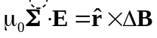
Where, under the assumption that the vertical current in the sheet is neglected, takes on the form:
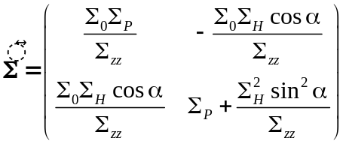
Here we define 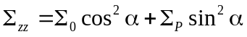 and α is the angle between the radial direction and the magnetic field, 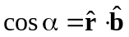. In terms of the latitude this is
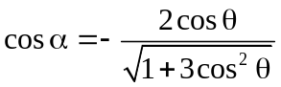
Remember that cos θ is positive in the northern hemisphere and negative in the southern. In this matrix the top row corresponds to the latitudinal (θ) component and the bottom to longitude φ. Thus, equation can be written explicitly as follows:
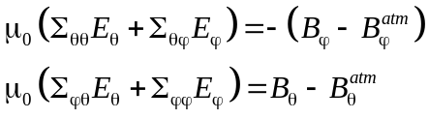
At the ionosphere the covariant basis vectors are
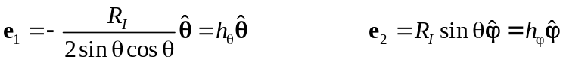
So 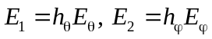and the same for the B’s. Thus, equation becomes
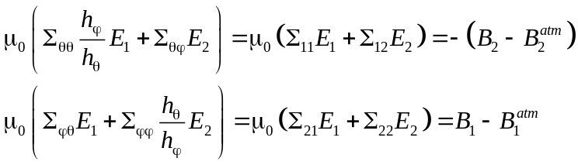
Inverting this matrix we find
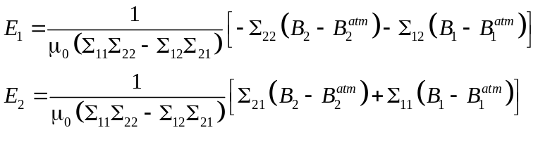

NOTE : The scale factor h_{i} must be calculate from the definitions of the appropriare e^{i}s. remembering the θ₀ means the colatitude in the northern hemispheres ionosphere and θ the colatitude at the appropriate ionosphere.

Numerical diffusion for instability

The main difficulty with the grid used is that it actually is composed of two sub-grids that are only weakly coupled, producing a phenomenon affectionately known as the “wigglies.” These two grids are those that couple electric field grid points with i+k even with magnetic field grid points with i+k odd and vice versa (here i denotes the grid point in u¹ and k with u³. In order to suppress these, it is helpful to introduce a bit of numerical diffusion into the system. It is most straightforward to do this by adding a diffusion term to Faraday’s Law. However, we want this feature to maintain the ∇∙B = 0 condition, which is written in covariant form as:
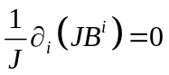

A scheme that does this modifies equation to read
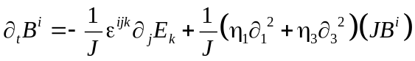
Using the usual three-point formula for the second derivatives, it can be seen that the diffusion term in equation couples the magnetic field at the (i,k) grid point with (i±1,k) and to (i,k±1). If the two η factors are constant, then it can be seen that
The last term is clearly zero; thus, if the divergence of B is zero at any time, then equation keeps it zero. Note that the different factors of η can be used since the grid spacings are different. The amount of diffusion will scale as 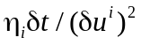. In our scheme δu³ = 1 while δu¹ = (1/L_{min} − 1/L_{max})/N_{x}, which is usually much less than 1.
Appendix: Equations with full metric tensor

First calculate the contravariant components of the current. As we had before:
Again, since 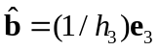, we get
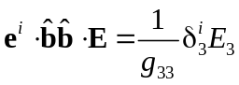
And
For i = 1:
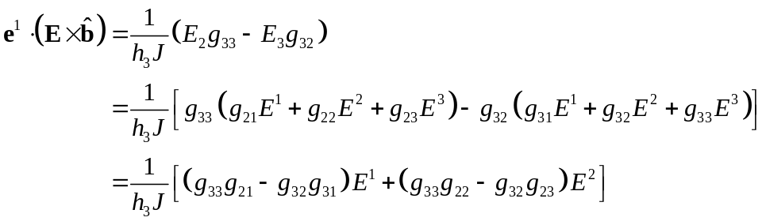
So
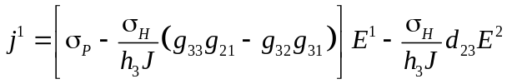
For i = 2,
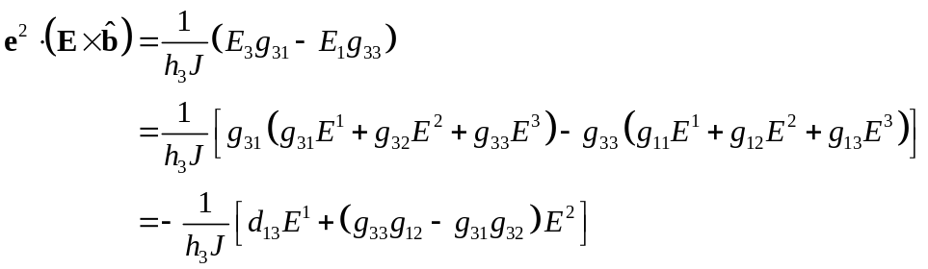
So
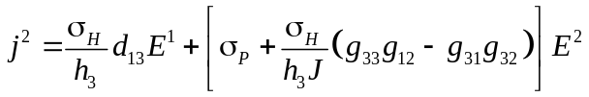

So now, the perpendicular parts of equations are generalized to become
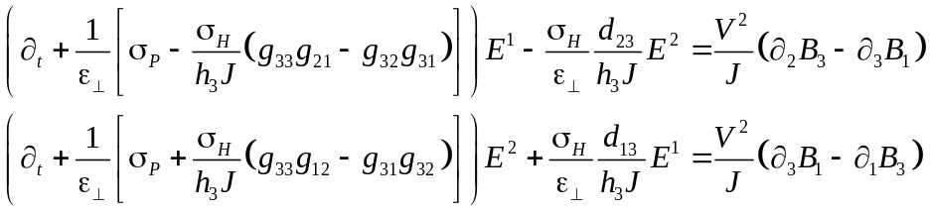
Equations can be written in the more compact form
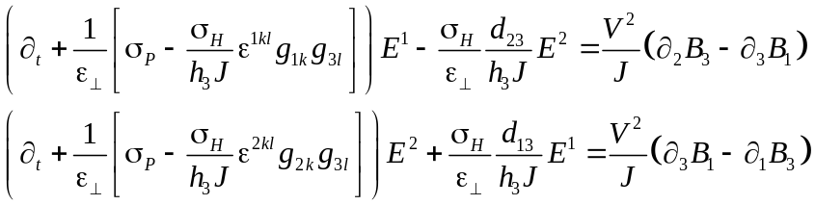
The generalization of the parallel electric field equation is pretty straightforward

